Thank you for your wall decal purchase. Your decal should be applied as soon as possible to prevent application issues. Your decal comes with transfer tape applied to help you easily install it. If you are installing a large decal, it is helpful to have a second person to help you. Wall decals may not stick to all paint finishes, dirty or soiled walls, or highly textured walls.
Supplies:
Decal
Vinyl applicator or old credit card
Level
String
Painters tape
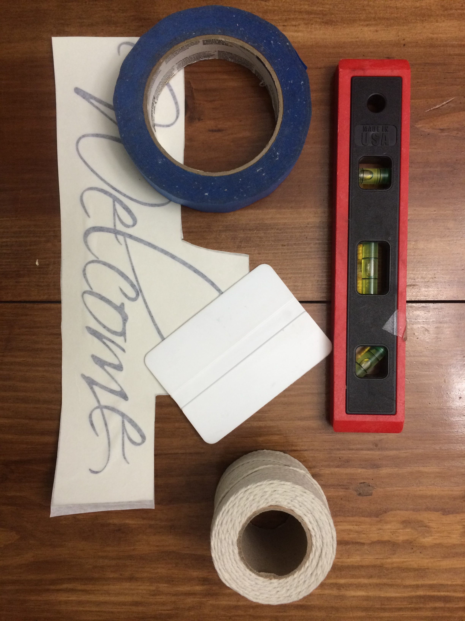
Step 1) Using your level and painters tape, tape a piece of string to the wall where you plan to install your wall decal.
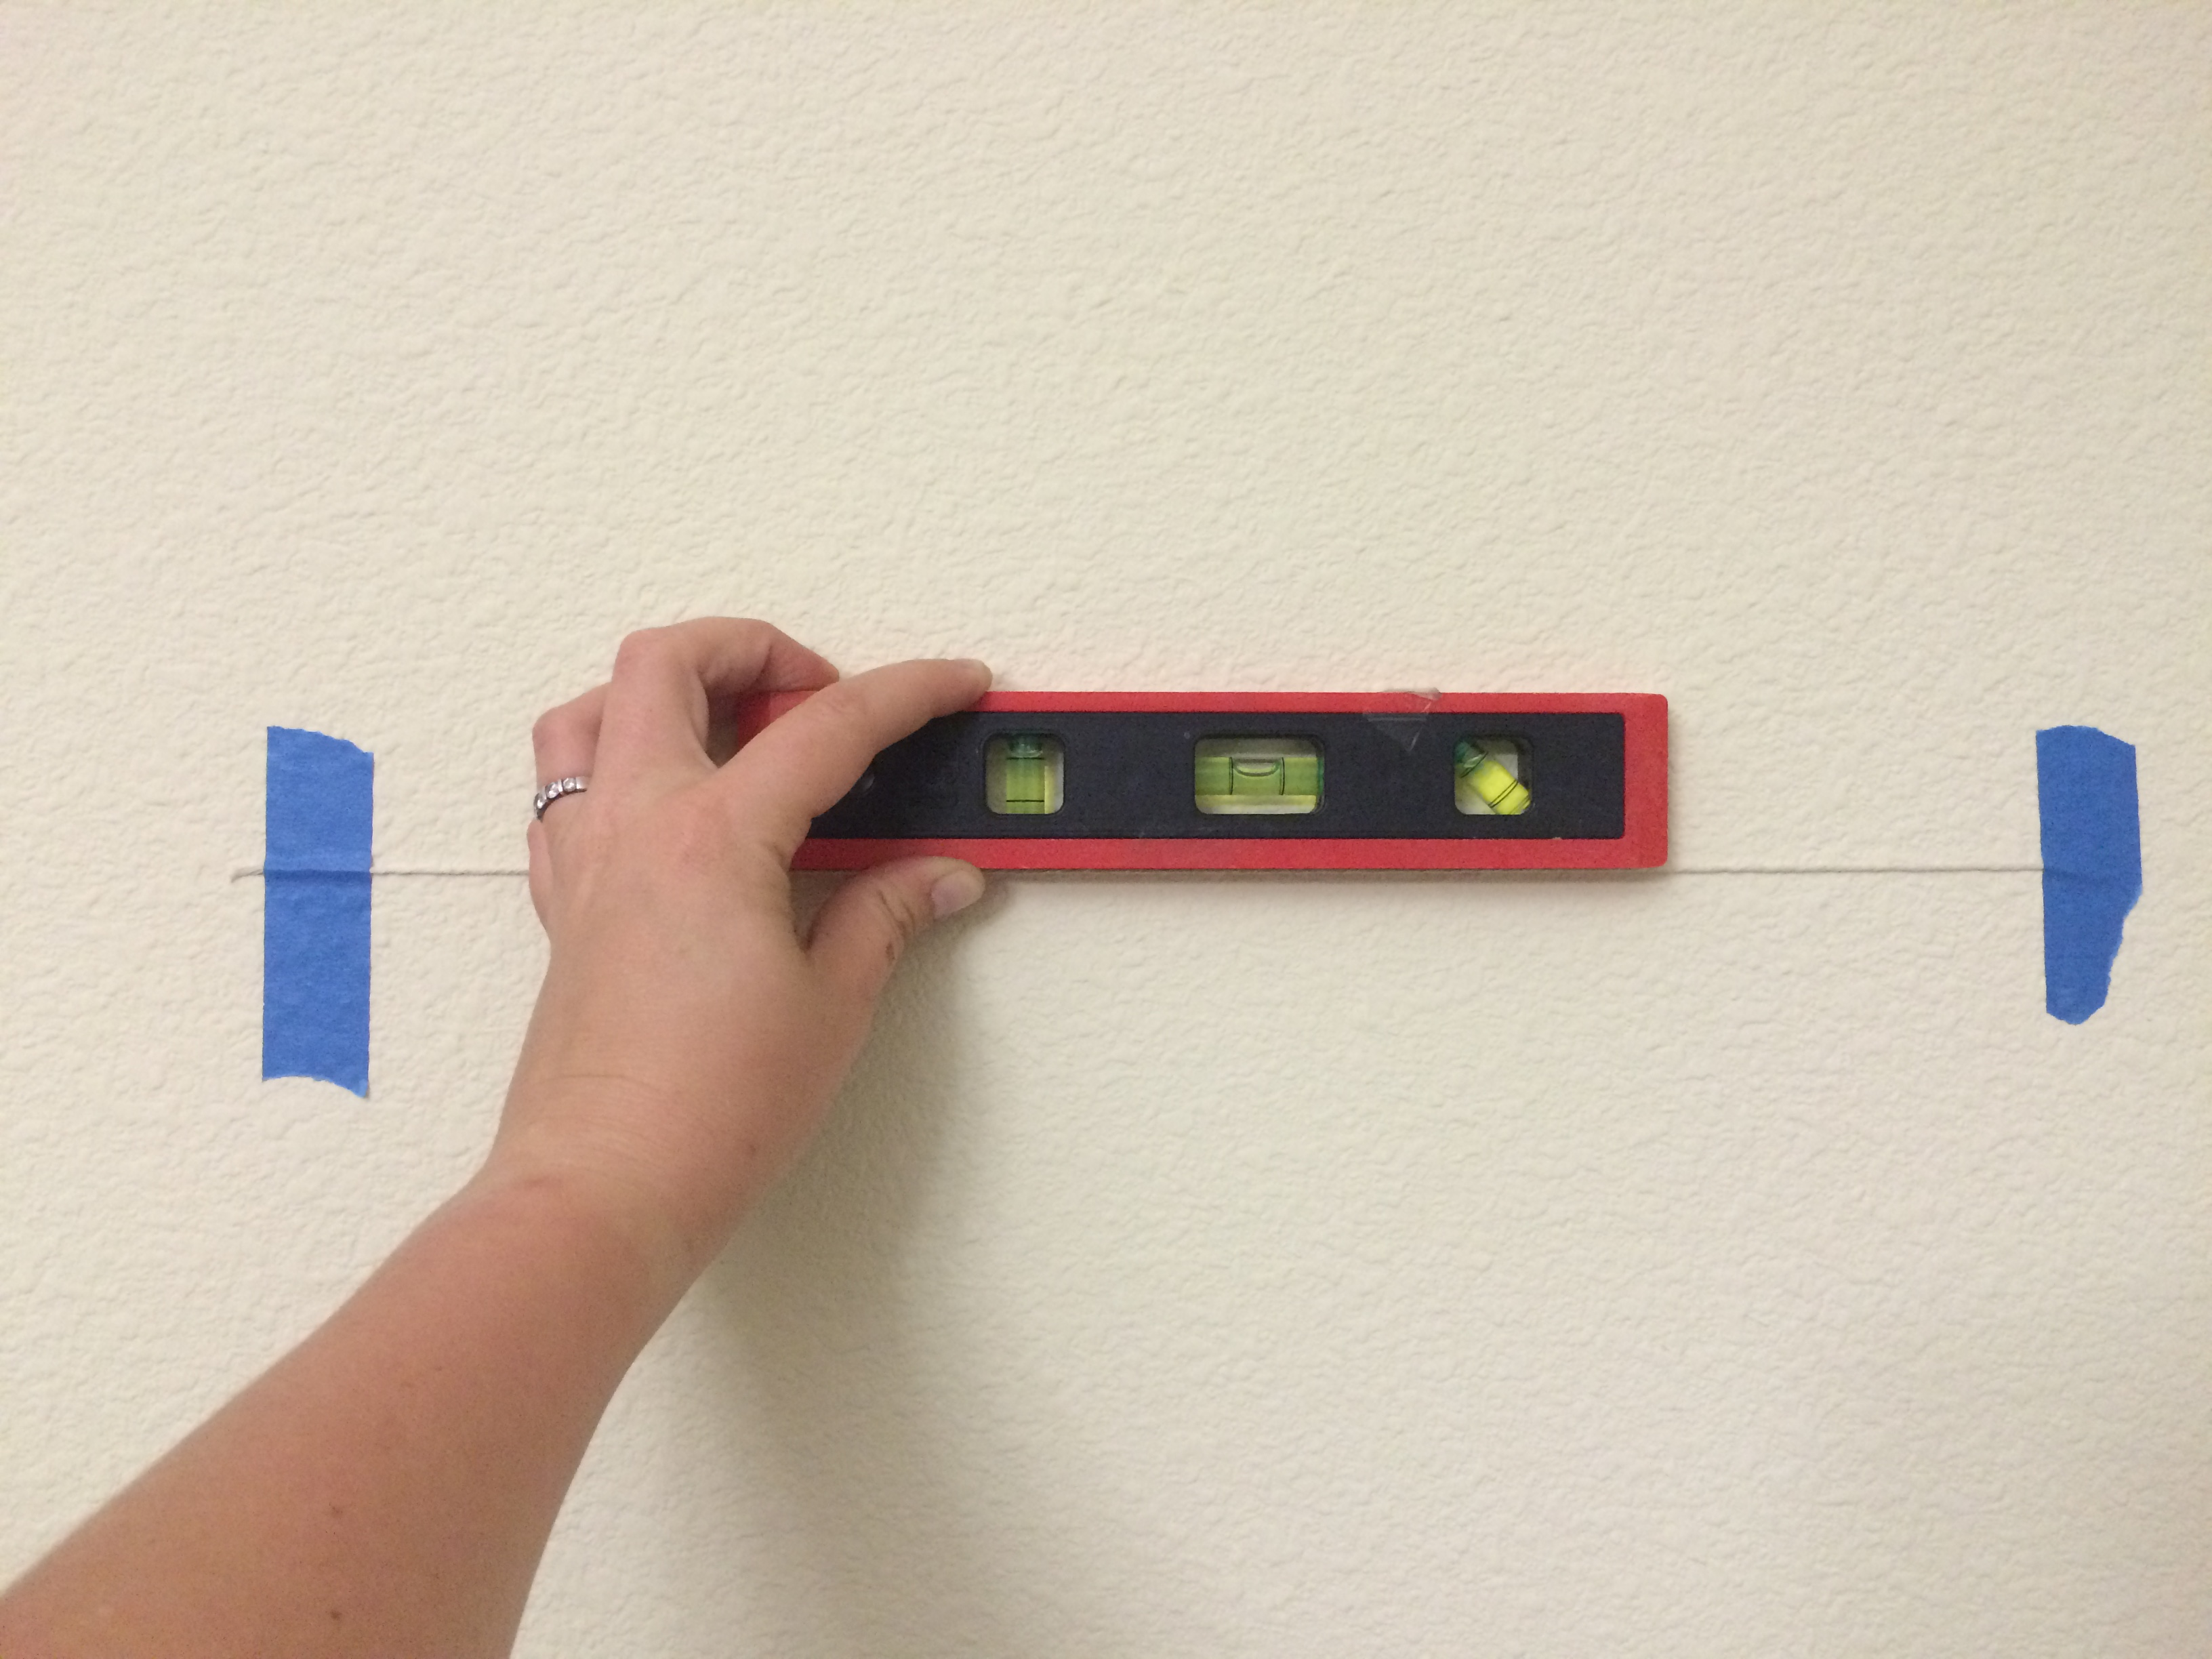
Step 2) Tape the top corners of the decal to the wall using painters tape and place a vertical piece of tape across the middle of the decal as shown in the photo below. The decal should be placed beneath the string, which you can use to make sure your decal is applied level on your wall.
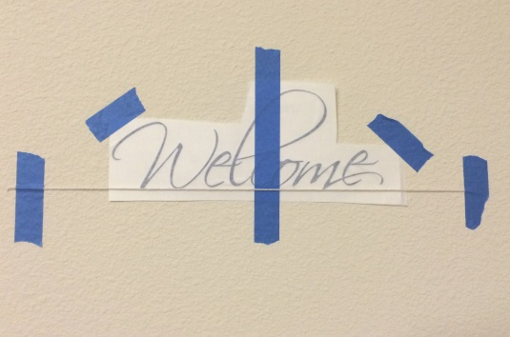
Step 3) Remove the string and discard.
Step 4) Remove the painters tape from the top left corner, and peel the backing paper off of the transfer tape. When you reach the center of the decal, tear the backing paper off.
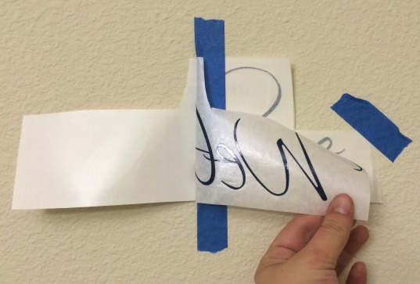
Step 5) Using the vinyl applicator, firmly rub the decal from the center point outwards to apply the decal to the wall.
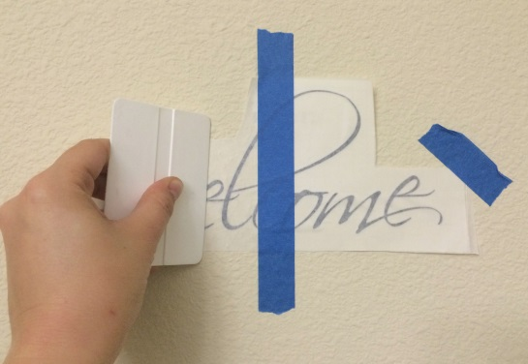
Step 6) Remove the painters tape from the center and right corner. Repeat steps 4 and 5 on the right side of the decal.
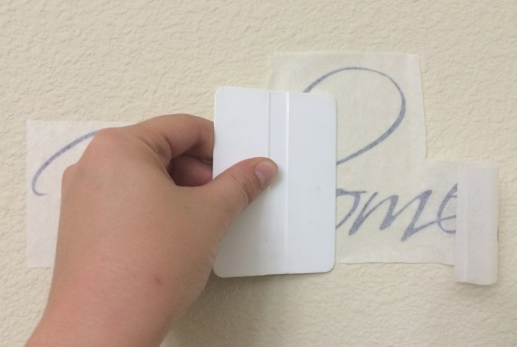
Step 7) Begin in a corner and slowly peel off the transfer tape at a 45 degree angle. Smooth the decal using the vinyl applicator to remove any air bubbles by rubbing from the center to the edges. Enjoy your decal!
