Thank you for your car decal purchase. Your decal should be applied as soon as possible to prevent application issues. Car decals should be applied only to surfaces with temperatures between 50 to 90 degrees Fahrenheit and should be allowed to cure for 24 hours before getting wet. Your decal comes with transfer tape applied to help you easily install it.

Supplies:
Decal
Isopropyl (rubbing) alcohol
Cotton balls
Vinyl applicator or old credit card

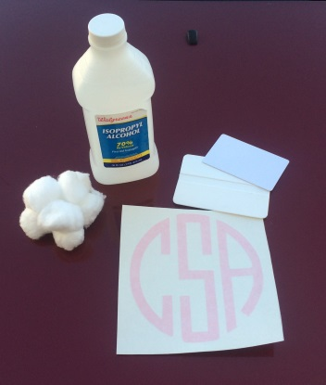

Step 1) Clean the surface where you will apply the decal with rubbing alcohol and a cotton ball. Allow it to dry.
Step 2) Beginning in a corner, peel the backing paper off of the transfer tape.
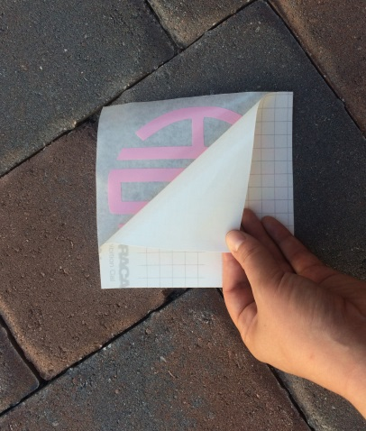
Step 3) Place one side of the transfer tape onto the surface, and press it down with the vinyl applicator.
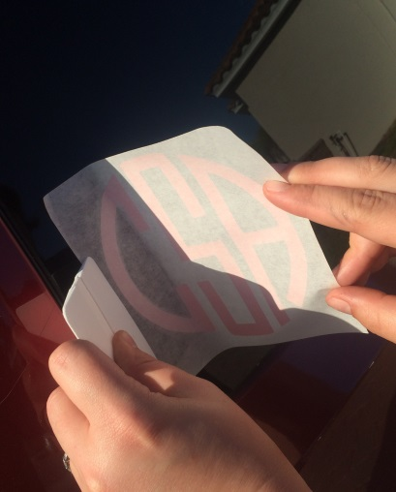
Step 4) Continue applying the decal in a rolling motion using the vinyl applicator to press it down as you go.
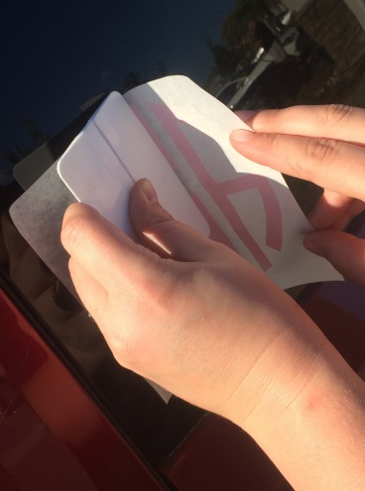
Step 5) Once the decal is placed, use the vinyl applicator and rub it firmly from the center point to the edges in all directions to remove air bubbles.
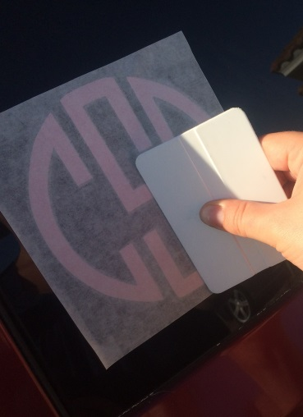
Step 6) Beginning in a corner, slowly peel away the transfer tape at a 45 degree angle. Enjoy your decal!
